This is what DEKLICA looks like in Ancient Egyptian Hieroglyphs


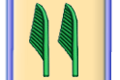


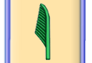




This is what ABCDEFGHIJKL looks like in Ancient Egyptian Hieroglyphs



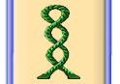
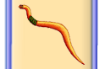

This is what MNOPQRSTUVY looks like in Ancient Egyptian Hieroglyphs
  
  
  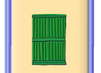
  
  
  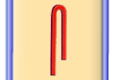
  
  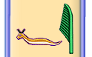
  To : k
  k.l@v.g
  From: g
  i.l@d.j
  Message:
  cvxcvxcvx
  

