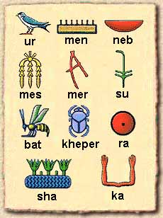

|  |  |  |  |  |  |  |  |  |  |  |
| --- | --- | --- | --- | --- | --- | --- | --- | --- | --- | --- |
|  |  |  |  |  |  | none | none | none | none | none |
| a | b | c | d | e | f | g | h | none | none | none |

abcdefgh

|  |  |  |  |  |  |  |  |  |  |  |
| --- | --- | --- | --- | --- | --- | --- | --- | --- | --- | --- |
| i | j | k | l | m | n | o | p | none | none | none |

ijklmnop

|  |  |  |  |  |  |  |  |  |  |  |
| --- | --- | --- | --- | --- | --- | --- | --- | --- | --- | --- |
| r | s | t | u | v | t | none | none | none | none | none |

rstuv

**[A](http://www.discoveringegypt.com/pics/a.gif)** - as in apple - picture of an eagle.  
[**B**](http://www.discoveringegypt.com/pics/b.gif) - as in 'bat' picture of a foot.  
[**W or O**](http://www.discoveringegypt.com/pics/wo.gif) -Two sounds - 'W' as in 'won' or 'OO' as in 'boot' - picture of a chick.  
[**KH**](http://www.discoveringegypt.com/pics/kh.gif) - ch as in 'loch' - picture - of a placenta.  
[**K**](http://www.discoveringegypt.com/pics/k.gif) - as in 'kitten' - picture of a basket.  
[**N**](http://www.discoveringegypt.com/pics/n.gif) - as in 'no' - picture of water.  
[**H**](http://www.discoveringegypt.com/pics/h.gif) - as in 'ha' picture of a twist of flax.  
[**I**](http://www.discoveringegypt.com/pics/i.gif) - ee as in feet - picture of a reed flower.  
[**G**](http://www.discoveringegypt.com/pics/g.gif) - as in 'gold' - picture of a stand.  
[**P**](http://www.discoveringegypt.com/pics/p.gif) - as in 'puppy' picture of a mat.  
[**F**](http://www.discoveringegypt.com/pics/f.gif) - as in 'fan' picture - horned snake.  
[**TH**](http://www.discoveringegypt.com/pics/th.gif) - picture of rope.  
[**M**](http://www.discoveringegypt.com/pics/m.gif) - as in 'mum' - picture of an owl.  
[**S**](http://www.discoveringegypt.com/pics/s.gif) - as in 'sit' - picture of a fold of cloth.  
[**J**](http://www.discoveringegypt.com/pics/j.gif) - dj as in 'edge' - picture of a snake.  
[**Y**](http://www.discoveringegypt.com/pics/y.gif) - as in 'baby' - picture of two reed flowers.  
[**SH**](http://www.discoveringegypt.com/pics/sh.gif) - as in shop - picture of a pool.  
[**D**](http://www.discoveringegypt.com/pics/d.gif) - as in 'dirt' picture of a hand.  
[**Q**](http://www.discoveringegypt.com/pics/q.gif) - as in 'quick' picture of a hill or slope.  
[**R**](http://www.discoveringegypt.com/pics/r.gif) - as in 'rat' picture of a mouth.  
[**T**](http://www.discoveringegypt.com/pics/t.gif) - as in 'two' picture of a loaf.  
[**L**](http://www.discoveringegypt.com/pics/l.gif) - picture of a lion.

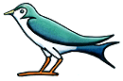ur

ra

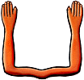ka

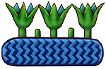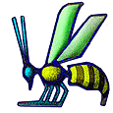sumen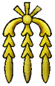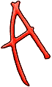neb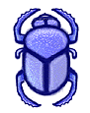

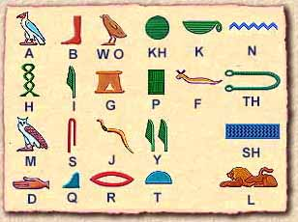

kh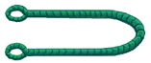th